INNOVATE PRACTICE WITH ‘’ENHANCING MANPOWER ABILITIES’’
By John Baptist Kamushaga-PhD fellow at MUST and Author of the book project.
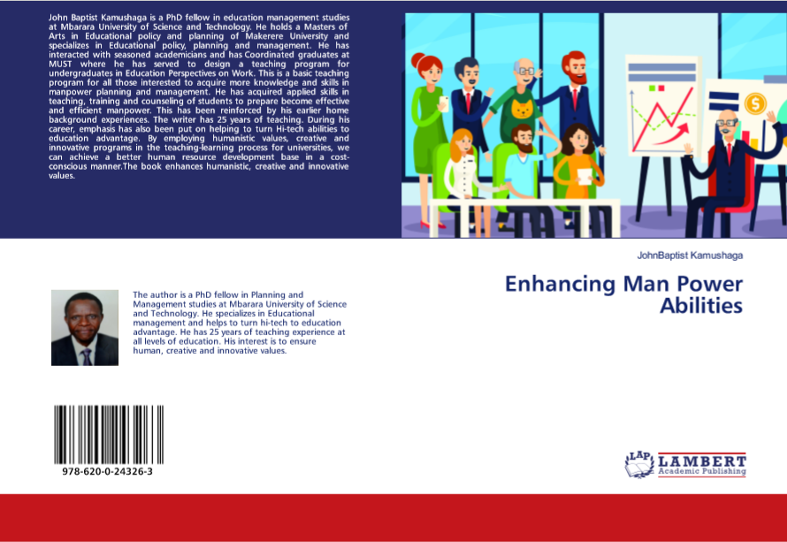
Background
‘’Enhancing manpower abilities’’ was authored as a result of the study conducted during the month of June-August 2018 which was a cross-sectional survey based on a total of 57 respondents;29 from the faculty of science and 28 from the faculty of interdisciplinary studies, all third-year students at MUST.
The research gave birth to a proposal for a course of study titled ‘’Education perspectives work’’ for university undergraduates which was submitted to the office in August 2018 for discussion and adoption.
To ensure better management and greater flexibility, building of several types of scenarios for policy implementation is recommended. So, I anticipated that there could be need to develop teaching-learning materials to enhance the university library, and the idea of writing a text book as a guide right came to my mind. This is how the innovation of Enhancing manpower abilities was born.
So, this project comes as a result of the author’s strict adherence to the logical process of moving from policy to action-although there is much more need to provoke institutional arrangements for policy implementation through constant peer reviews and harmonization.
As a research fellow(PhD) at the faculty of science and a professional, this project is believed to further prepare fresh university students/graduates to be oriented in the world of work as human resource developers, have job access and multi-skills and competences which would fill the missing link between the best of education preparation and the needs of education in Uganda and the world at large.
The book project is the additional guide for planning and managing the curriculum for university students and any educational program serving the learning needs of people.
As a basic point of reference, it is expected to build positive attitude of a student/person towards work so that they are not left behind in the developing period of hi-tech.
The way the book is philosophically organized in four parts; asceticism, romanticism, pragmatism and humanism giving ample amounts of illustrations from the world of work, enables the students to practice and expand their career and work for the country in future.
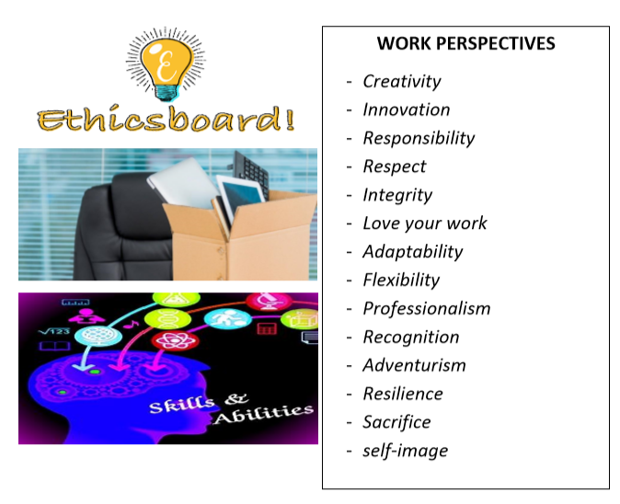
The great founded opportunity in the current Ugandan education landscape and the world in general is that there is no basic teaching tool kit of this make. For a fact this is a new learning area for Mbarara university on the road to continue securing a place to innovate practice. This unique difference makes this book project ‘’stand out of the crowd.’’
Secondly, this text book blends home background experiences with twenty-five years of work in the formal sector. Remember, home experience provides a foundation for career success. This is an area those in the parenting office must emphasize
Thirdly, the book project is based on the recognition that the learners need to get exposed to a diversity of educational learning experiences that include creative, innovative, and humanistic values. Coming from a humanistic learning area of study, the project attempts to ensure human resource competitiveness, survival and belonging, leveraging on stretch, hence continuous improvement,
Therefore, since the project is specifically meant to upraise the quality of university education, aspiring human resource persons and students must invest in this, have the knowledge incorporated in their courses to hold them to course objectives of beginning accountability…..
Product launch date is on the 16th oct.2019 at campus. Proposed Venue: Pharmacology Lecture Theater. Other updates, always follow this website page.
Best regards

